29 UK BN NCC

DBS PG COLLEGE

**Dehradun**

# 7R’S CIRCULAR ECONOMY

# Economy aims to keep products, components, and materials at their highest utility and value, at all times. The way to do this is to focus on the principals of the model, commonly known as the “7 R’s” of circular economy.

# Rethink 2.Reduce 3.Re-use 4.Refurbish 5.Recover 6.Recycle 7.Repair

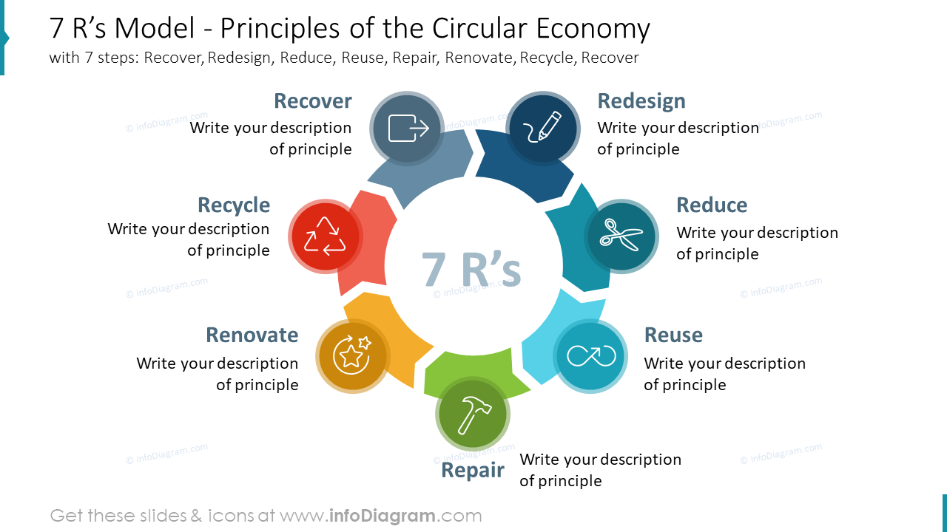**Report**

**Event-**7r Circular Economy

**Date-** 18th June, 2024

**Venue-** College

On Tuesday , 18 june 2024 cadet of 5/29UK BN NCC D.B.S PG COLLEGE Dehradun Organize a awareness Campaign , in this campaign we conduct a Speech to aware about 7rs of circular economy

|  |  |  |  |  |
| --- | --- | --- | --- | --- |
| **DATE** | **NAME OF ACTIVITY** | **LOCATION** | **PARTICIPATION OF CDT** | **REMARK** |
| 18 June  2024 | 7r circular economy | DBS PG COLLEGE | 50 |  |

The cadets of the institution completed 7R Circular Economy under the command of CPT DR. DIVESH SINGH

